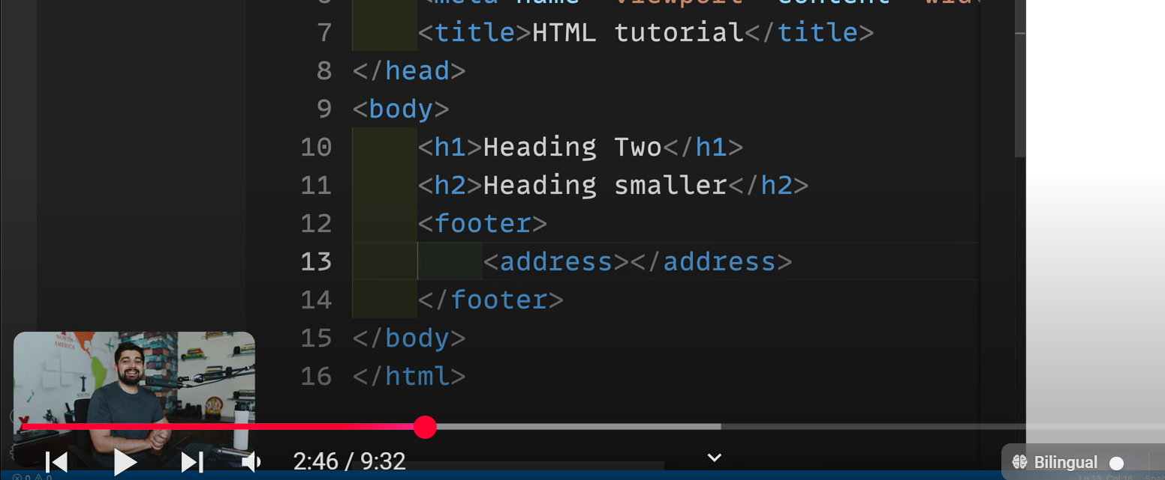

Writing address in add. Tag in footer helps in ranking webstes in google without paying

Every tag in html has a importance

Html ke instead browser could hv xml, latex etc.

(65) Core structure of HTML and Meta tags | Hindi - YouTube

https://www.youtube.com/watch?v=v-xdY6VFcio

To support smilie on webpage we use UTF-16

Transcript:

(00:00) Yes, welcome back to Chai and Court. Now that everyone has understood how to get the first page of HTML, how to install VS Code, and how we have to write our code first, let's talk a little about it. I know HTML very well and all of you know that the heading inside the H1 tag is bigger.

(00:22) When you write the H2 tag, the heading always appears a little smaller but that is not the reason behind it. There is also a reason and that will make your HTML foundation course structure strong. A lot of people think that okay, H1 tag is for big headings and H1 is for smaller headings, but I know that many of you know that By using this you can make any h2 tag bigger than the h1 heading, then what is the point of writing everything in HTML in paragraphs, why is there a need to pay so much attention to HTML, there is a need to pay attention If we

(00:58) call HTML then we will also see a new full form of a markup language which is You can read on Google there is a markup language but I don't want you to remember it today, unmarkup language, I want you to remember it today, unsyntextual language, simple and declarative language, what this language does is it creates the structure of your page So this is a structural language and it is not just that there is only one structural language, there are many other structural languages ​​inside, many people also divide it into

(01:23) presentation structure language and description language and there are many more names, you need to know No, HTML is not the only structured language, you also have Smackdown, LaTeX, and many other languages, but its support is the highest in the browser, that is why HD is so popular and all its tags are a unique language in themselves. We keep it important.

(01:46) H1 does not mean that the heading will be bigger there and h2 does not mean that the heading will be smaller there. H1 means that all these headings inside the page are the core part of the page. This is the most important thing. Kind of like when you're heading When you write, this is a subheading, it is second and important and all the search engines like Google, Yahoo, index etc understand these things very well.

(02:07) You must have noticed that many people simply write footer and inside the footer they write paragraph. And here you can write your address, there is no problem as you can take it to the footer as well but a lot of people don't have to spend anything to give their ranking and their address on Google and write simply After that, you include all your paragraphs inside the address tag, Google knows it automatically because you knew the structure of the HTML language very well, Google knows it, it took your address from the address in the structure

(02:38) and saved it, so it is HTML. The better the knowledge you will have, not because it makes the headings bigger or smaller, but because the importance of each tag makes the structure of your page, I think HTML is looking more interesting now, okay, so let's start first to know what for It is important and what else should we know, as soon as we typed exclamation mark and hit enter, first of all we got to know that okay this is the basic structure, but as soon as we went to the first line, we found all the tags of two types of HTML.

(03:10) We call all these as tags. All these taxes are case sensitive. You can write head if you want, it doesn't make any difference, but usually in most cases you keep them in lower case, the first tag is This is the doc type. As I told you, in the initial phase of the internet, there was not just HTML, there was also XML, apart from that there was XHTML, there was also Latex, so your document can be of any type.

(03:38) This thing only tells the browser that this The document which we are serving is of HTML type, after this we said HTML and obviously the whole HTML has become popular in India and abroad, so the language also has to be defined whether it is in English or Hindi where it is not in this is it or If it is in some other language, after that we remove the most important part here, the structure of an HTML is like this and to know more about it, HTML is always like this, two children of another HTML It is important for us to know this terminology

(04:09) because after this we will also learn DOM and all this is important for DOM. Notice here that there is HTML, inside it we have two children, head and body, and inside the body you can create more children. You can add all children inside the head, like I added a title, I just gave it to you simply by adding a title inside the body and writing it is test, so our relation in HTML is with the title.

(04:38) This is grand child, now it is not like that you have to go inside some round of grand grand child care, usually parent child and grand child have relationship limited to this only and there can be more, it is not like that, there is another A tag inside h1 here also And more values ​​can be added, but they won't do that for you.

(04:53) It is important to know that I will tell you all those things here. So in HTML we wrote head and inside head we wrote body. Now when we go to a web page, whatever you see on the page here, all this is your body. The part which is the visual aspect of the head, only two things are visual in it, the first part is your title and the second is Favicon, now on whichever website you go, you will find a small icon here I have got a small icon of the VS code, all these are there and it is not that you need to remember the syntax, you just need to know that

(05:23) I have to apply Favicon, so you simply go here and simply like you type inside the title Fevicol will write that if you want to add an image, it will suggest you the middle, it will do that as well but not for now, right now we have come to know this much, now we saw that as soon as we did all this work, one more thing used to come and that was meta tags.

(05:43) Now what is this meta text? It is some information about your document which you can put on the page. I don't want to write but any automatic bot role that comes to visit the page or the server or any space should know all this like the character set that we are using in this page is alias 16, there are many character sets Like if you want to support smiley on the page then I will support it in alias 16 here we will also read about sky characters and things now you have written the name view port and with device that means when this page is rendered by default

(06:14) then What is its zoom level, how does it look on a tablet, how does it look on the website, it's all about that, so from where do we get to know all this, the best resource that I thought if you want to see about meta tags is Meta Tags in HD. And the best part is on Google because Google recommends developer.

(06:39) google from all the votes that will help you the most in the development of your website, here you should put all these tags like name description [music] Now you know that you can find all types of tags directly, such as Do you need a tag with description or do you

(07:43) need a texture with edge, whatever you want, I want a description, so you can simply write the name description and any content description here, you can directly write it, we get everything loaded on this page. Many times we will see that in a tight part, now only this much, okay so now you know that there is dog type HTML, our HTML is there, inside it there is head, there is body, now you should know one more important thing, notice the head is opening and It is also closing, the body is also opening and closing, this is the syntax

(08:12) but it is dog type which is only opening, not closing, nine this is a recommendation that if you open any tag So close it as well, like if there is a heading tag then close it as well, the browser will not give you any problem, you can simply write heading here and if you want you can remove it, it will still serve you the page, HTML is the most relevant one It doesn't give you any errors Usually but this is not a good thing because when you will learn later on react or learn any other language then this practice is very important there and yes

(08:44) errors come without these some tags though do not have closing tags like b tag that is a standard loan it is called The best way to write this later in React is that React gives an error in this because this is not a closing tag so we can make it self closing this is a more efficient way to be future proof so these are all our tags, elements also these It is called tags or you can name them as you like.

(09:10) Simply this is h1, this is our tag. There can be some attributes inside the tags as well, but for now, that is all you have understood, what is head tag and you know the basics. Now we can go a little faster to learn what are h1 tags, what is their importance, do they have any other attributes or what are attributes, so let's go through all this in the next video and quickly This covers all our tags that are important.

(09:32)

Video 3:

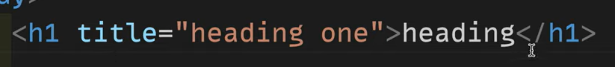

Pura ko html elmnt kehte ha including closing and ending tag

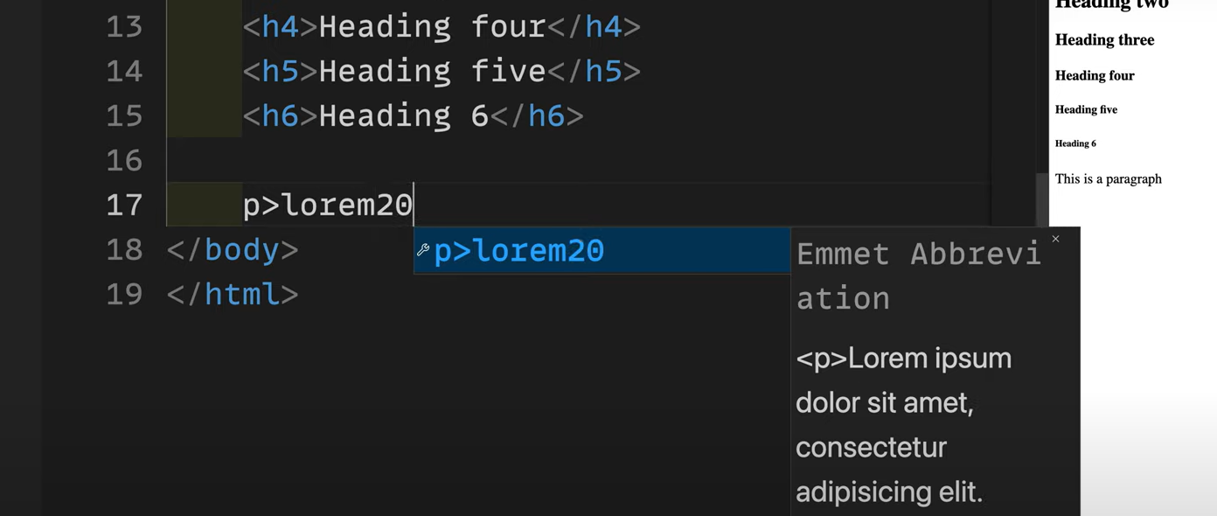

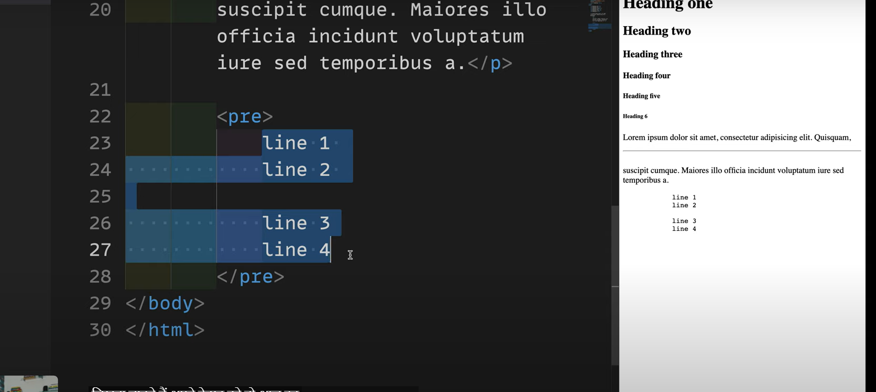

Pre tag ke andar jo bhi likho waise hi browser display krega…..it will not even ignore spaces

(65) Heading, paragraph and reading docs | Hindi - YouTube

https://www.youtube.com/watch?v=CetKwpx3t6g

Transcript:

(00:00) Yes, welcome to all of you in Chai and Court, another episode in the HTML series. So in this video we will simply see what are the other elements of HTML, HTML tags, elements, attributes and you will need to make 500 videos about all these in HTML. There is no need if you cover the basics and foundation of HTML properly then it can be done in just a few videos.

(00:22) In this video, we will increase the length a little so that we can focus on each of our topics. If you can do it, then let's start without any delay. So we are working on this file. This is this file. By now we have come to know what is doc type, what are document types, what is HTML, you can know a little about these in small steps.

(00:42) Let's talk about it so that it will be easy for us in the future when we are learning Java script or some other language. The first thing you should know is that there are some keywords inside HTML like HTML element tags and attributes, see this Yes, this is simply an element. Not only H1 is included in an element. Element means this H1 which is the starting tag is also a part of it.

(01:08) Whatever data you have written in it, it is all a part of it, so from the beginning till the end. Whatever it is, this is all our HTML element. After this, the thing you are seeing is our tag name. Now this is not just the tag name. Along with this tag, we can add some more properties like for example We add the title here, so I will write here simply heading van and nothing happens with this but you can see the whole part here, here all these are HTML elements, yes this is also included.

(01:39) This is the complete element from start to end, but the tags are here, we will go ahead and learn to modify HTML elements, when is the data inside it being stored inside our VRavel, when is its attribute being stored, JavaScript I am very very It is important, now let's talk a little bit about it, not much, the first and foremost part is, I'll go to view here and word wrap it so that you can see everything at once or we can expand it a little more Let's do it.

(02:23) Ok, the most important thing is that please do not forget to close any element. If it does not close, then keep it self-closing. We saw this in the last video as well. Even if you do not do it, there is no problem. It happens but when you read React or any other language, you will see that it creates a problem.

(02:40) You will also see that many web pages or examples are written in capital h1. You can also write it, but I don't. I write this because HTML is not case sensitive, so I prefer that everything should be in lower case and apart from this, you need to know only one more thing, that is that you can do nesting even inside many elements.

(02:59) are like for For example, nesting is already done here that there is h1 tag inside the body, so similarly you can include other tags as well, like suppose you have written h2 tag, inside it written heading, now you have to put this heading after the heading, which is yours Or it is three, you have to keep it in a pan and span is also a type of tag, so by keeping it inside this, you can write here, for example, when we do it later, it becomes very easy to target any element.

(03:28) So these can be interlinked, they can be intermixed, that's all you need to know about this topic right now, let's talk a little about the attributes, just like a person has attributes, stall His short is like many headings and many tags have their own attributes. You do n't need to know about all the attributes right now.

(03:52) We will definitely discuss some attributes here. Like for example a new tag, we are here, the anchor tag which is simply used to open a new tag, so here you will see that by default its attribute is f man, we need a reference of hyperlink reference, where should I go On any other web page or any website, this attribute which is a compulsory character for this tag, it does not track it like for example if I write Google here then Google will be there but now you can click on it and see the text Can't go anywhere, let's

(04:22) open it in a browser, so here I go to Simply Extension and I enable it as well, so here I go, right click, open with live server and open it here. This is our second and here when we click on Google, nothing happens. Why does this not happen? Because we have a tag, we have not filled its compulsory value. In many code projects, you will see that when the value is not filled here, If you want to do something then simply a has is put on which this The reference is that these values ​​are not going anywhere, I will fill its value later

(05:07) or right now it does not have any value, if you want to fill the value then you can simply give the complete resource here like http s column slash slash And google.com but not only this, there are many other references here as we will read more references in detail later, like for example, now I will tell you another shortcut of Amit here A and call now see here there is black, there is link, there is mail, there is oil, all of them have different uses like for example if I click on black then it adds only one value that is

(05:43) target underscore black now there are many values ​​here Like when you press control and space then you will get suggestions in cs code like black parents self and top now I don't know the meaning of all these or how to reduce them so for all these I simply go to google and type I'd recommend the best research as you can on the Mozilla Developer Network So you will get to know all the things about the anchor like attributes, there can be so many attributes like download can be an attribute, we have already heard about it, there is

(06:16) another attribute here also pink is also an attribute here, referral Policy is also an attribute so you can see there are many attributes like here we have just seen target is an element so self when we write d current browser context in simple words it opens it in the same browser only when You write underscore black usually and new then by opening the new then it opens its website or whatever resource you have, similarly there are parents and top also now the most important thing is that we on this entire

(06:43) channel and in fact Whenever I teach people, I tell them how important it is to go to the documentation because any tutorial will tell you about each and every F, it will tell you about a tax, but this So it is certain that something will be missing, so it is most important that we go to the attributes here and see what other attributes can be there inside h, so we saw that the download attribute can be one, achara It can be a fattribute and it can also be a ping attribute, so take some time and go through it and

(07:13) learn about all the attributes here, you don't need to know about properties, examples and everything in detail right now when There will also be some, we will discuss that. Right now your only assignment is to go and click on the attributes of all the taxes that I have discussed and see what all attributes are available with us.

(07:32) Now this is just a matter of coming. We will discuss more about attack in detail later on but every element, every tag, has some compulsory attributes and some non-compulsory as we have seen title here is non It is compulsory but it does not make any difference but if you want working of Aate then there are compulsory attributes like Aate, this much is enough to know here, as more will come to us we will get more details about them like images When we talk about it, we will see its compulsory attributes.

(08:03) Now we see an interesting thing here as we wrote heading and inside it we wrote heading van and heading as soon as you click on it and move the mouse over it, you can see it. The heading van arrived there. So this is all that the title has to offer and when these titles come, you can modify them further through tool tips etc.

(08:20) So this is all the basics that we have. Now let's extend this page a little more here. And let's start exploring our tags. So the first tag we have is heading. So we'll create a file with the name heading dot html. From here we'll speed run the exclamation mark tablet quickly. Now we've written the heading inside the document here.

(08:43) What we will do here is we will quickly see all the types of headings and also read their documentation, so first of all h1 comes, so we wrote heading van we did it and when we open it, we will close it with its Also needed and here we write live server live server so our heading is gone shortcut we read about Vasco which is your option shift and press the down arrow key duplicate you have added a value and shortcuts here You will read that you click here, press your option key and alt key and click one more

(09:25) time, now you have two air hoses, you can edit all of them at the same time, it is important to know these shortcuts, so here we have given them Heading van and now we are late heading you heading you have also come to us so in the same way we have six types of headings and there is also h5 which is very rarely used because if your documentation is so abstract that your If you need so many headings then maybe you need a new page but still there is heading till six so it is necessary for me to write so heading five

(10:04) and after that we have similar headings all right so heading Six is ​​done, we have a very small one. Now after this we quickly go here and read about the headings. Now here you can find out about everything, but first of all you have to go here to read the headings. We went to the heading element and saw that these are headings, now we just have to We are looking at its attributes, inside the headings we can see that there are not many attribute headings here, there are not many values ​​inside it, if we look at the attributes then there are

(10:36) not so many special attributes, you can do it with the title attribute, so that It is common but we have seen that there is something extra here, otherwise it is a simple thing, there is no need to take so much load on the headings because the tax is the simplest of the easy, okay after this there is another type of heading which comes to us or we have to write tax Whatever comes, it comes simply through the paragraph.

(10:57) Now, whenever you go and write inside the paragraph, suppose you write anything, it takes a lot of time to write this paragraph. So, our focus, our attention is that we should know about tax. I want to learn that which is missing for us, so the best way for this is to do it in Amity, how will we do it in paragraph, after that we will do it with arrows and write laurab, now how many words do you need for laurab app, you can write that here as suggested Do I need 20 words.

(11:23) I will write 20 and tablet them. And the 20 words are placed there. I go to view here and word wrap it so that I can see everything at once. So now my focus is completely on knowing this. This is how paragraph tag works, not knowing what I have to write inside it, from where I can copy paste the text and write it, it is very simple, inside this we get to know about some tags which we will use later There will be less like for example whatever word is written here, question, I do n't know what is written here after this if I

(11:51) hit enter on the line now I want everything in a new line, if I do it then it does n't make any difference in the HTML, so here But I get some options like BR tag which breaks the line, now the line has broken here but this is the ideal option because whatever react etc. you will read further, it will come in handy, so you should write brush and get used to it, it will be better It will remain there for you and not only this, if you wish you can also put a We can also draw horizontal lines as we can see here and here, if a line is

(12:20) inserted here, then HTML does not know about our line breaks and this is a classic problem which you will see in any HTML documentation you read. w3c's mdm's classic poem problem which is called the classic poem problem inside the paragraph how to solve it there are two-three ways i will tell you all of them i don't know poem but still i have to tell you all the details so Here we add paragraphs and as we write poem [music], in this way we write some poems but as we can see here we have taken the link inside the HTML but it does

(13:08) not look like a poem If it is there then there can be many options how do you deal with it first of all I will come here and enter the B tag [Music] so another tag which you will see sometimes is the tag Preet tag, it is done automatically Some browser defaults Formatting is done the way you want to write your text, it comes in whatever line space you give it, however much you do it, now along with this I want to tell you one more thing, I do not go to the Pritak campus for this If it is inside then the pre tax which

(14:09) goes inside the HTML here we will have to search the pre tag again or the best way is to directly write on Google Preet Preet how much complex is not there, we will see the star pattern whatever you want to print it is best that you can print it for free Add that in the tag all the attributes when you look at it there are not that many attributes but still there are like columns weight wrap we can see brother by default some columns have been shifted here if you want how many columns you need then You can see it accordingly, there are

(14:42) some examples here as well that how you can use free tax by default, apart from that you can try it with some attributes as to how many columns you need, how many weights you need as I have mentioned. I told you that anyone, you are taking training in HTML, you are learning it It is most important to go to the documentation.

(15:01) Now the most important thing is to notify the documentation. Here you have an exclamation sign and there is also a delete sign, a trash can. Look here, it is written in front of both of these that deprecated men, now this does not happen to him. If yes then most browsers will not support it, there is also a warning that this is not a standard, so if you are using free tag then earlier we could provide columns etc.

(15:21) but now we cannot provide it, we can provide it but most of the browsers do not support it. Whenever you are reading, you also get the history of when and how it used to happen earlier and now you get to know about it, then this is how these documentations are read or during the whole series, in fact on the whole channel, I will tell you that the documentation How to study because that is what will make you a real developer, not tutorials, keep watching and subscribe too, so here our free tags are posted, we have learned all these details

(15:47) here, okay this was our basic pre-tech key how can we reduce it Now in many places you will see that you use this pre tag and mostly it is used for codes like for example if we write console dot log here which is a very famous good and script concept then we write hello Notice here, in this way you can write all your code here and how we can modify it later, at least all the spaces that are there in our text will be respected, all of them are here But it will be done, then you will see that it was not that difficult

(16:20) and we have covered all the important things for us in just one video. In the next video, we will cover more tags in the same way and will definitely read the most important documentation if you subscribe. let's meet in the next video